
Faculty of Engineering
Department of Electrical and Computer Engineering
Examination Solutions for:
Course No. and Title: | EE4212 Computer Vision
Semester/Year: | II, 2009/2010
Solution to Qn No. (& Marks): | 1 (25 marks)

(a) (8 marks: 5+3)
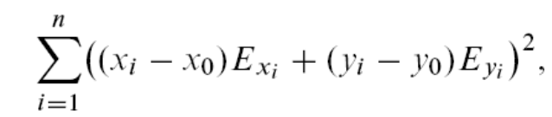
where (x_{i} ,y_{i} ) are the positions of n “critical’’ points in the image, while 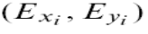are the brightness gradients at these points. This method does not need to go through the process of optical flow estimation which itself typically involves smoothness assumption.

(b) (7 marks)
If the scene in view is fronto-parallel, then depth is constant for all points. Let the inverted scaled depth T_{z}/Z be k.
(kx − kx₀)E_{x} + (ky −k y₀)E_{y} = -E_{t}
The unknowns in this linear system of equations are k, x₀’=kx₀, y₀’=ky₀. Again we can form a linear system of equations. Once k is known, (x₀, y₀) can be recovered from (x₀’, y₀’).

(c) (5 marks):
The normal gradient (p_{x},p_{y}) at each measurement (x_{i}, y_{i}) to the emanating lines from the FOE is (y_{i} , -x_{i}).
(u_{i}, v_{i}) . (p_{xi},p_{yi}) = (u_{i} ^{rot}, v_{i} ^{rot}) . (p_{xi},p_{yi})
where
u_{i} ^{rot} =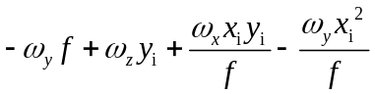
v_{i} ^{rot} =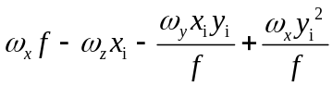
This will yield a linear equation for each measurement point. Collecting all i from 1 to n, we obtain a linear system of equations for the rotational parameters.

(d) (5 marks)
1: NW direction; 2: W; 3:S.
Aperture problem at 1
Unique corner at 2
Spurious corner at 3.

Faculty of Engineering
Department of Electrical and Computer Engineering
Examination Solutions for:
Course No. and Title: | EE4212 Computer Vision
Semester/Year: | II, 2009/2010
Solution to Qn No. (& Marks): | 2 (25 marks)

(a) (3 marks) F (x_{i} ,y_{i}, 1 )^{T} will yield the equation of line in homogeneous representation.

(b) (4 marks) No, this is not correct. Need to impose rank 2 constraint on F by SVD technique learnt in class (by imposing the last singular value of F to 0).

(c) (4 marks) A geometrically meaningful criteria should be the distance between the feature point 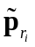 and the right epipolar line 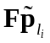. The criterion in the classical 8 point algorithm lacks a normalizing factor that makes it a image distance measurement.

(d) (10 marks: 4+4+2) The left epipole is given by null(E) = [0.6210 0.7836 0.0156]T
Scale the whole vector such that the last coordinate becomes f, that is, 15.6mm (i.e. multiply by 1000); the first 2 coordinates yield the left epipole; (621, 783.6) mm.
We know E is rank 2 because it is skew-symmetric.

(e) (4 marks): repetitive features that look similar locally, possibly resulting in a significant number of outliers. Somewhat difference in lighting conditions in the two images.
Faculty of Engineering
Department of Electrical and Computer Engineering
Examination Solutions for:
Course No. and Title: | EE4212 Computer Vision
Semester/Year: | II, 2009/2010
Solution to Qn No. (& Marks): | 3 (25 marks)

(a)(10 marks:8+2)
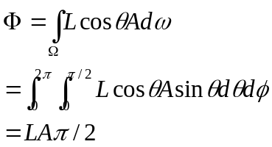
The amount of received radiant power does not depend on d.

b)(15 marks: 13+2)
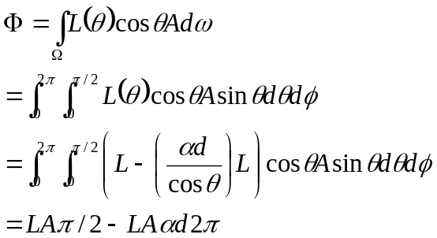
This amount depends on d.
Faculty of Engineering
Department of Electrical and Computer Engineering
Examination Solutions for:
Course No. and Title: | EE4212 Computer Vision
Semester/Year: | II, 2009/2010
Solution to Qn No. (& Marks): | 4 (25 marks)

(a)(17 marks: 4+5+8)
Choose k data point to act as cluster centers
Iterate the following steps until the cluster centers are unchanged.
1. Allocate each data point to clusters whose center is nearest according to the distance
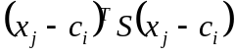
2. Calculate a center for each cluster by
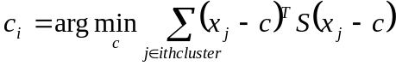

(b) (8 marks)
Each cluster needs to have at least one element. The new center can be computed by solving the following equation about
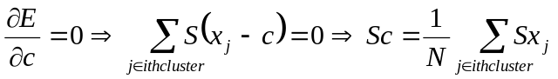.
N is the number of elements belong to the cluster i.

